LUMI阅读作业分析模板-TPO

TPO__R__——文章名称：_____________

Report截图：          用时：__min.



（上图为示范，用自己的截图替换即可）

词汇：生词+熟词僻义+词组

**生词**：



（上图为示范，将生词直接添加到小站托福的生词本，用自己的截图替换即可）

**词组：**

示范：be susceptible to 受...影响

长难句每篇找3句(把主干用横线画出来，修辞画括号，重点逻辑词标黄)：

示范：1. Evidence suggests that an important stimulus （behind the rise of early civilizations ）was the development of settled agriculture, （which unleashed a series of changes in the organization of human communities）（ that culminated in the rise of large ancient empires.）

（不用做）每篇1个长段落分析【主要讨论对象（抽象/具体）+代词/逻辑词】：

示范：【Paragraph 5】Not only could Smith identify rock strata by the fossils they contained, he could also see a pattern emerging: certain fossils always appear in more ancient sediments while others begin to be seen as the strata become more recent. By following the fossils, Smith was able to put all the strata of England's earth into relative temporal sequence. About the same time, Georges Cuvier made the same discovery while studying the rocks around Paris. Soon it was realized that this principle of faunal (animal) succession was valid not only in England or France but virtually everywhere. It was actually a principle of floral succession as well, because plants showed the same transformation through time as did fauna. 例子Limestone may be found in the Cambrian or-300 million years later-in the Jurassic strata but a trilobite—the ubiquitous marine arthropod that had its birth in the Cambrian—will never be found in Jurassic strata, nor a dinosaur in the Cambrian.

（不用做）文章结构：段落关键词：讨论对象（+ADJ./ADV.）

示范：Westward migration的原因

1. BG.

2. characteristics

3. attractions: land+banks

4. transportation: turnpikes

5. transportation: steamboat + Erie Canal

错题分析 （截图请截完整！！！选项和原文都要截图，这也是方便以后复习哦）

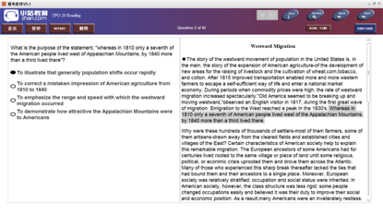

(上图为示范，，用自己的截图替换即可)

错题题号：；正选：；我选：【绝对不能抄软件解析，要根据思维导图的方法来进行分析】

1. 错题题型判断：

2. 正确的做题思路：

3. 正确选项跟原文的同义替换：

4. 错选选项问题：(如果没想明白，写上自己不理解的地方)

5. 其他错误选项问题：(如果没想明白，写上自己不理解的地方)

6. 总结注意事项：